Unique Identity: AR0305
Region: North America
Jurisdiction: CA
Category: Environment
Title: Canada. Toronto Municipal Code. Environmental Reporting and Disclosure Bylaw Schedule A to Ch. 423 Priority Substances (as amended through 15 June 2011)
Step 01: Click the link and scroll down the page https://www.toronto.ca/legdocs/bylaws/lawmcode.htm?1751371857621
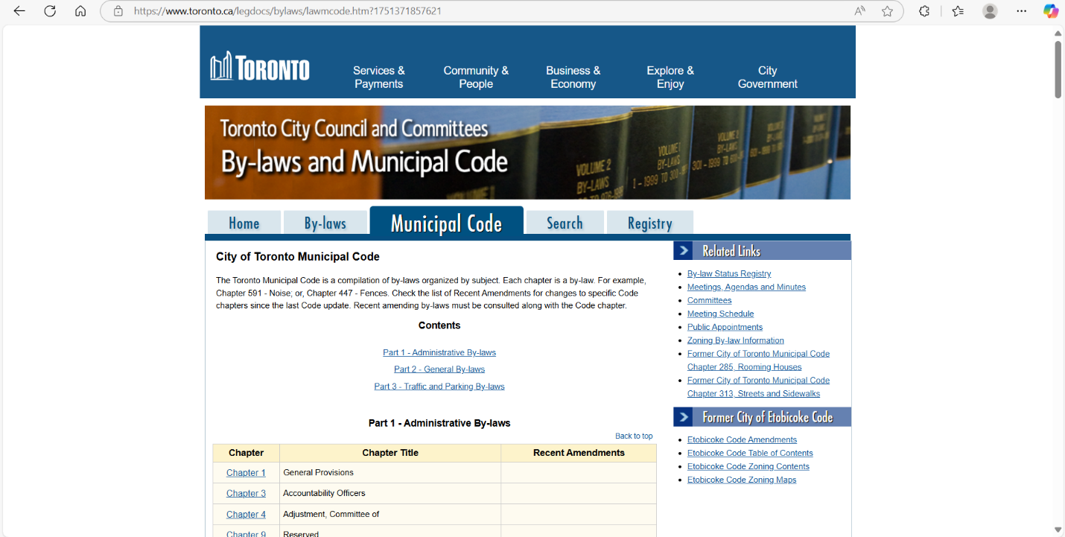

Step 02: Click on the highlighted region (Chapter 423)
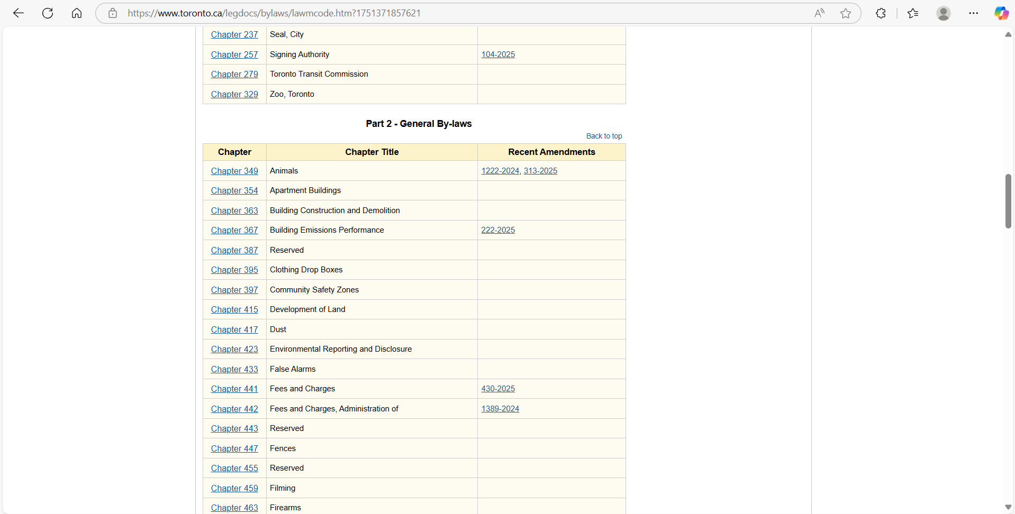
Step 03: Go to Page 8
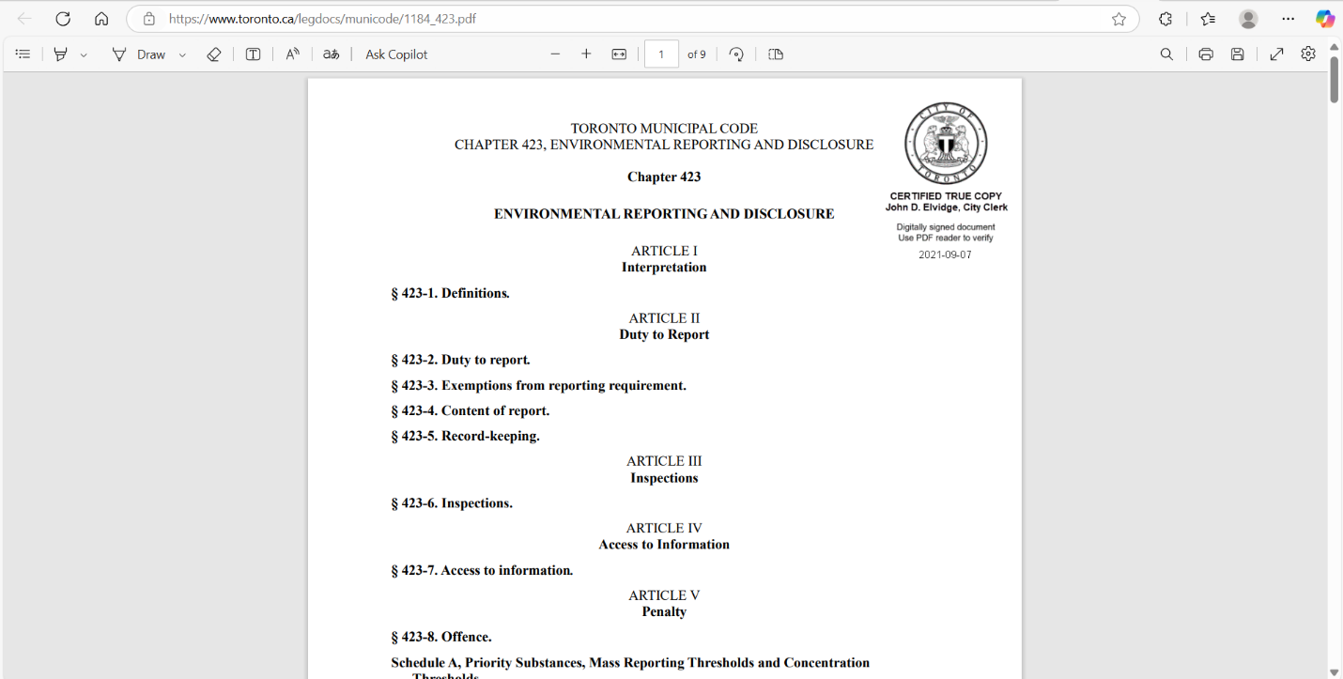

Step 04: The list can be seen as follows
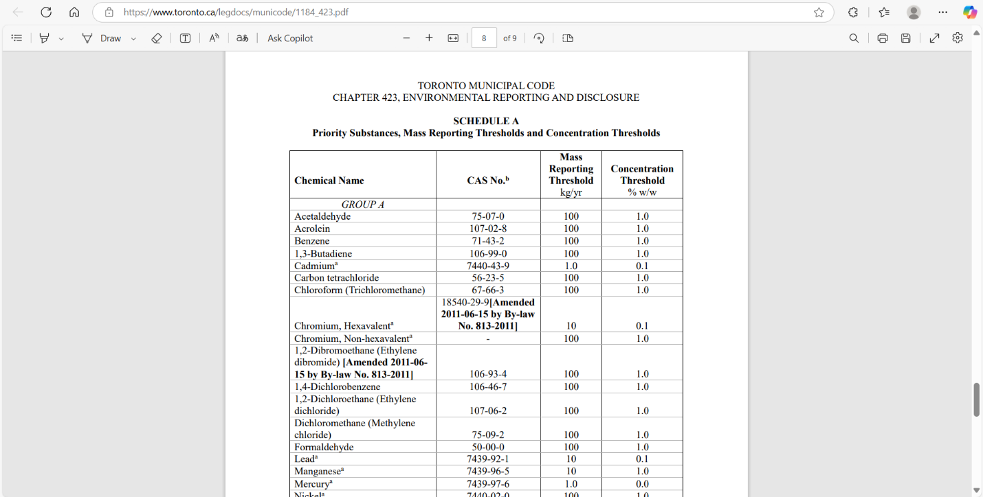
Step 05: Data Extraction
- Extract all the data in page 08 and use “Chemical Name,” “CAS No,” “Mass Reporting Threshold kg/yr,” and “Concentration Threshold” as keys in the JSON.

…………………………………………………..
Client’s Feedback: OK

